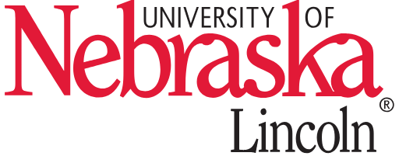niconniconN icon, red Speech & Debate Team

___________________________________________________________________________________________________________________

358 Louise Pound Hall / Lincoln NE 68588-0329/ https:/<https://comm.unl.edu/speech-and-debate>

N icon, red

CORNHUSKER SUMMER FORENSICS INSTITUTE

N icon, redN icon, red

N icon, redN icon, red

2022

The University of Nebraska-Lincoln proudly announces the return of the Cornhusker Summer Forensics Institute for the 18th consecutive year. The dates for this year's speech camp are July 20-24th. Campers staying in the dorms will arrive on the evening of Wednesday the 17th and leave the afternoon of Sunday the 24th. Commuters will begin attending on Thursday morning.

This year's speech camp will feature sessions on Program Oral Interpretation, Humorous Interpretation, Extemporaneous Speaking, Dramatic Interpretation, Oratory/persuasion, Poetry, Duo Interpretation/Duet Acting, Informative speaking, and an advance writing section for experienced students in public address:

Students of all abilities and levels of experience are welcome.

The cost the Speech camp will be $500 which will include:

* Four nights of stay at one of the university's air conditioned dorm rooms
* Three meals a day for each full day of the camp
* Four days of instruction and practice from top flight councilors including former national and state champions.
* Access to University of Nebraska-Lincoln's extensive collection of plays and literature
* A variety of handouts and tips that students can take back to their teams and coaches
* One on one coaching and group sessions with our coaching staff, featuring some of the best high school and college coaches in the nation. For more on our counselors please visit: <http://www.huskerspeechcamp.com/counselors>
* Scholarships based on financial need available

The cost for commuter students is $275 and includes lunch on Thursday, Friday, and Saturday

If you have suggestions for the camp, wish to obtain more information about it, or want to attend, please feel free to contact me. Our goal is to meet your needs and we want to accommodate your desires to create the best camp experience possible. Camp applications are due on July 1st.

**For more info visit**

**http://www.huskerspeechcamp.com/**

Aaron Duncan, Ph.D.

Director of Speech & Debate  
University of Nebraska-Lincoln   
375 Pound Hall   
aduncan3@unl.edu N icon, redN icon, redN icon, red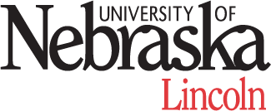N icon, redN icon, red